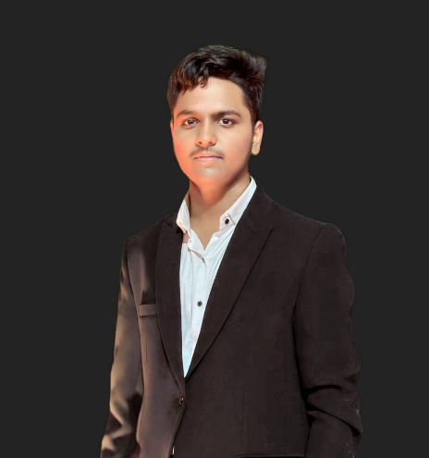**Girish Chavan**

**Address:** Mhetrewadi, Chikhali, Pune - 411062

**Phone**: 70200-54957

**Email:** officialgirishschavan2005@gmail.com

**Portfolio:** https://gcalaone2005.github.io/GirishChavan-Portfolio/

**LinkedIn:** www.linkedin.com/in/girish-chavan-8a0a00284

**Objective**



I aspire to become an expert in Web Development or Software Development, with the goal of working as a Full Stack Developer in a leading MNC. Additionally, I aim to gain valuable experience and insights in the IT industry to eventually establish my own IT company.

**Skills**



**Technical Skills**

* Programming Languages: C, C++, PHP, Python.
* Web Technologies: HTML, CSS, JavaScript.
* Databases: DBMS, SQL.
* AI Tools: ChatGPT, Claude, BlackBox AI, Copilot.

**Soft Skills**

* Teamwork & Collaboration
* Adaptability
* Team Leading

**Projects**

**Signature Silicon – Tech with Purpose**

*Web developer and Publishing Intern (In progress)*

*Website link:* [*Signature Silicon Pvt Ltd*](https://sisiwebsite.netlify.app/)

* Leading a tech startup focused on building user-friendly digital solutions.
* Working on MVP and concept design of smart tools for real-life problems.
* Tech Stack: HTML, CSS, JavaScript, Bootstrap (Future: React JS , node JS)

**CoderX – Developer Learning Hub**

*(Completed)*

* Curated educational site for web & software dev
* Organized tech stacks: frontend, backend, DevOps
* Tech: HTML, CSS, JS, GitHub Pages

**Portfolio – Personal Developer Showcase**

*(Completed)*

*Website link:* [*visit me*](https://gcalaone2005.github.io/GirishChavan-Portfolio/)

* Responsive site showcasing projects, skills & achievements
* Modern UI with sections: About, Skills, Projects, Contact
* Tech: HTML, CSS, JS, Bootstrap, GitHub Pages

**Experience**

**Web Development Intern –** **Visit us**

Signature Silicon Pvt Ltd – Pune (Remote)

(June 2025 – Present)

* Developed and deployed user-friendly interfaces
* Gained experience with Git, Netlify, and responsive design
* Worked closely with team members to meet agile sprint goals

**Education**



**MIT Arts, Commerce and Science College, Alandi**

BBA (Computer Applications) | Current - 2024 |

CGPA: 8.03

**Novel Jr. College**

12th (Science) Board (HSC) | 2021 - 2023 |

Percentage: 71.67%

**S. M. Dr. D. Y. Patil English Medium School**

10th Board (SSC) | 2021 |

Percentage: 58%

**Certifications**



**Cybersecurity Analyst Simulation – *Tata Group (Forage)***

*(May 2025)*

Hands-on IAM and cybersecurity fundamentals.

**Generative AI Career Essentials – *Microsoft & LinkedIn***

*(Mar 2025)*

Covered GenAI basics and ethics.

**HTML Tutorial – Great Learning**

*(Mar 2024)*

Intro to HTML and web structure.

**Database Management System – *Great Learning***

*(Feb 2024)*

Basics of DBMS and SQL.

**Hobbies & Interests**

* Drawing & Sketching
* Cooking
* Historical Films & Documentaries
* Music
* Learning New Tech – AI tools and Technologies
* Community Contribution - Sharing knowledge and gaining experience through community involvement.